Phase 3 is still pending. However, I had selected an ideal speed for and created an out of bounds feature that will trigger an automatic game over when crossed by players. Refer to figure 1.2.

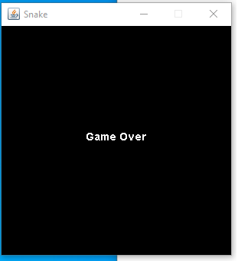

Figure1.2

The Grid size from phase 2 has also been coded into the snake game. The goal for phase 4 is to polish my code, fix any remaining bugs and test all games with my team members.